St10241408

Wede5020 part 1

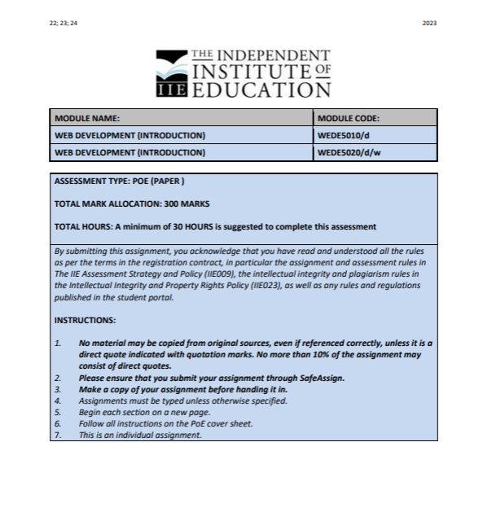

Table of Contents

1.The essay 2

2. The website pages and content 2

1.Hompeage 2

2.Book online page 4

3.Services page 5

4.Contact Us Page 7

5.About Us 8

3. References 9

# 1.The essay

***Beauty Signatures***

The business I’ve decided to help and create a website for which will have an online presence is called **Beauty Signatures** owned by **Adonay Mushilange**. She is a makeup artist and hairstylist, basically a creative being who needs more recognition. A well designed and structured website will make the business look professional and legitimate; thereby providing confidence in the user to engage. I will be designing the brand and making it look unique and easily identifiable to customers. The logo colour themes are white, black and two different shades of purple. Which I intend to use in the website design. The sole purpose of creating this website for this business is to help her to be able to communicate with her clients when she isn’t available and to make arrangements online without a hassle. She would like to have clients book sessions with her ahead of time so I would like to create a contact us page which allows her clients and future clients to be able to use. She then needs a page that shows off her work so I decided that a profile page is needed so it can showcase her work. In the homepage that I will create will be the introduction to her brand what’s it about, the aim of the homepage is to make sure the customer finds it easy to navigate through the website and so she can add announcements or things she would like to share with the users for an example a discount she’s providing etc. I will then have an about us page which will show the owner of the brand and go into detail about who she is and where to find her if the customer wishes to follow her on her socials. The contact us page will be created so that customers who have an inquiry or dispute can contact the numbers available or send an email to Adonay. Creating this website will make life easier and hassle free, the goal is to make it accessible to anyone who wants to look up the salon online which will then provide it with an online presence and increases the brand visibility and revenue.

# 2. The website pages and content

## 1.Hompeage

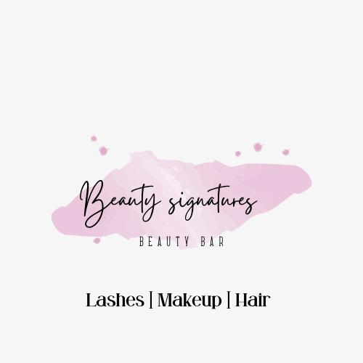

Home Book Online Services Portfolio Contact Us About Us

**Unveiling Beauty, One Brushstroke at a Time.**

Beauty Signatures is taking modern beauty to a whole new level. Beauty Signatures’ mission is to connect our clients with our team of talented beauty professionals to provide luxury on the beauty experience to elevate your beauty and confidence. We want to provide you the luxury of having your own beauty squad to take care of all your beauty needs from extensions to braids, in the most convenient way possible in the comfort of your home or location of choice.

we wanted to offer something that was convenient for the girl on the go, while giving you the luxury of having your own personal glam team. The best part? all of our services are delivered to you. Exclusively on site only.

**professional tools**



**quality tools**



**hair washing**



**Like you look so cute rn;)**

©2023 Beauty Signatures. All Rights Reserved.

## 2.Book online page

***Appointment Booking***

Top of Form

Full Name:   
Email:   
Phone:   
Select Service:                                                                                                                                                                                                             
Select Date:   
Select Time:   


Feel free to contact us for other custom hair styles.

Like you look so cute rn;)

©2023 Beauty Signatures. All Rights Reserved.

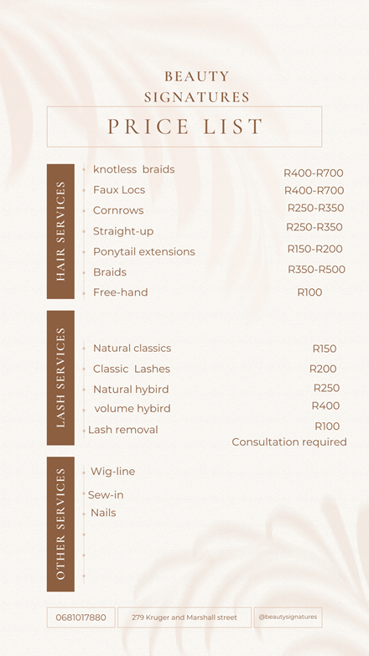

## 3.Services page

***Services***

**hair styling**

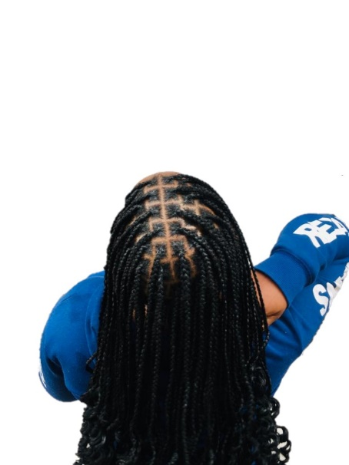

**lashes**

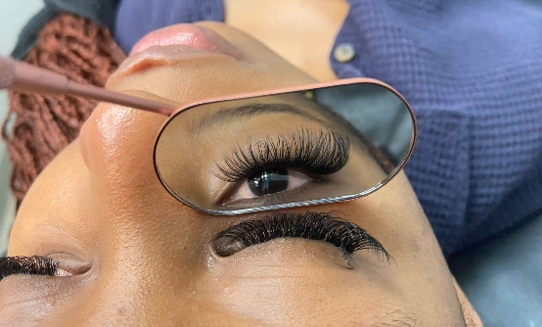

**eyebrow tint**

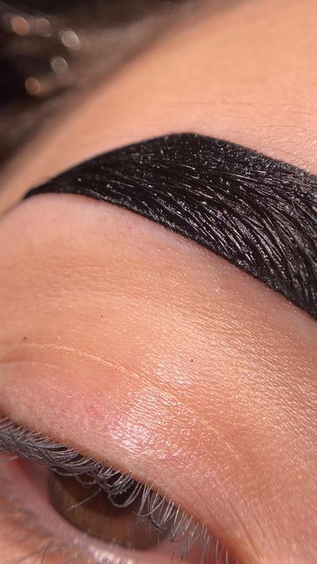

**full make-up**

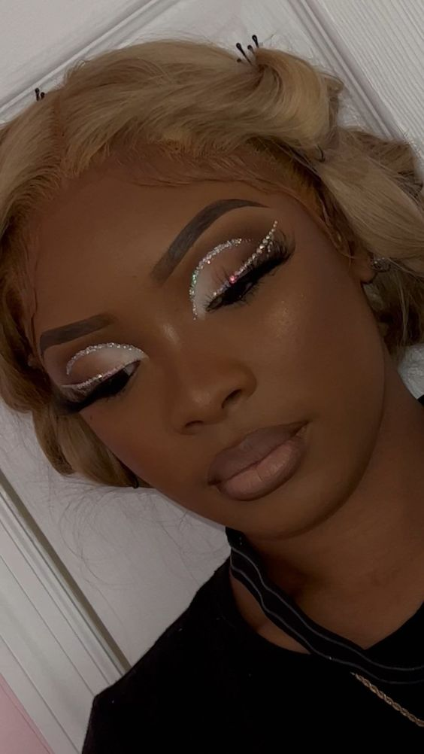

**soft glam**

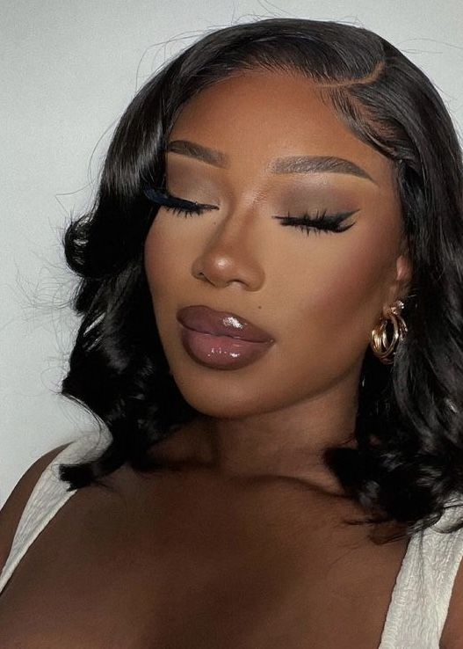

Like you look so cute rn;)

©2023 Beauty Signatures. All Rights Reserved.

## 4.Contact Us Page

***Contact us.***

Please feel free to connect with us and book your appointment and we will gladly get back to you:)

Your name



Your email address

Your cell no.

Your message



Send Message

**Our info.**

Adonaymushilange@gmail.com

0681017880

Working times: 08:00-18:00

Monday to Saturday

House calls available

**Find Us.**

Like you look so cute rn;)

©2023 Beauty Signatures. All Rights Reserved.

## 5.About Us

***Our story***

**Unveiling Beauty, One Brushstroke at a Time**.

At Beauty Signatures, we believe that beauty is a canvas waiting to be revealed, and each stroke of a brush or a careful twist of a curling iron is a brushstroke in a masterpiece. With a passion for enhancing natural beauty and a commitment to personalized artistry, we are more than just makeup stylists and hair-dressers; we are creators of confidence, curators of elegance, and architects of self-expression. Adonay set out to create a space where clients could experience the transformative power of expert makeup and hairstyling. we draw inspiration from the latest trends, timeless classics, and the individual features of our clients, ensuring that every look we create is an unforgettable masterpiece.

What sets us apart is our unwavering commitment to not only enhance external beauty but also to empower our clients from within. We believe that makeup and hairstyling are not about masking flaws, but about highlighting individuality. It's about embracing every unique feature and celebrating the inherent beauty that lies within each person. Our studio is a sanctuary of creativity and comfort, designed to make every client feel welcome, relaxed, and pampered. We take pride in using only premium, cruelty-free products and state-of-the-art tools, ensuring that every application is not only stunning but also safe for your skin and hair. Whether it's for a special occasion, a photoshoot, or simply a day you want to feel extraordinary, we are here to turn your vision into reality. Our consultations are a collaborative experience, where we listen attentively to your desires and offer expert advice to achieve the perfect look for you.

**Meet the creative behind the scenes**

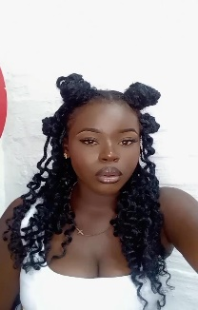

***Adonay*** is the name of the creative behind this amazing brand.

A highly resourceful, creative and innovative makeup artist and hair stylist who is self-motivated and possesses impeccable communication skill. Experienced in ensuring customers, models and performers have suitable makeup and hairstyles before they appear in front of a camera or audience.

find her on the socials:

 [instagram](https://instagram.com/ladessesignatures?igshid=MzRlODBiNWFlZA==)

Thank you for considering Beauty Signatures as your trusted beauty partner. We look forward to being a part of your journey, enhancing your natural radiance, and creating moments of beauty that last a lifetime.

Like you look so cute rn;)

©2023 Beauty Signatures. All Rights Reserved.

# References

adonay's picture. (2023, september 14).

*pinterest* . (2022). Retrieved from full glam look: https://pin.it/1Wea7zS

*pinterest*. (2023). Retrieved from https://pin.it/6MkI31d

*pinterest*. (2023). Retrieved from lash equipment: https://pin.it/2HwMMbk

*pinterest*. (2023). Retrieved from eyebrow tint: https://pin.it/6lvcMwW